**SUPPORT VECTOR MACHINE**

**Business Problem** = ﻿ ﻿Prepare support vector machines model for classifying the area under fire for foresfires data

* **Name of the File: -** fireforests.csv
* **Size of the File: -** 49 KB
* **Req. Data: -** 517 Observation, 28 Variable

**Exploratory data Analysis** =

* **Outliers: -**  Profit variable having outliers.
* **Missing Value: -** Data don’t have Missing Values
* **Normality: -** Data are near normal

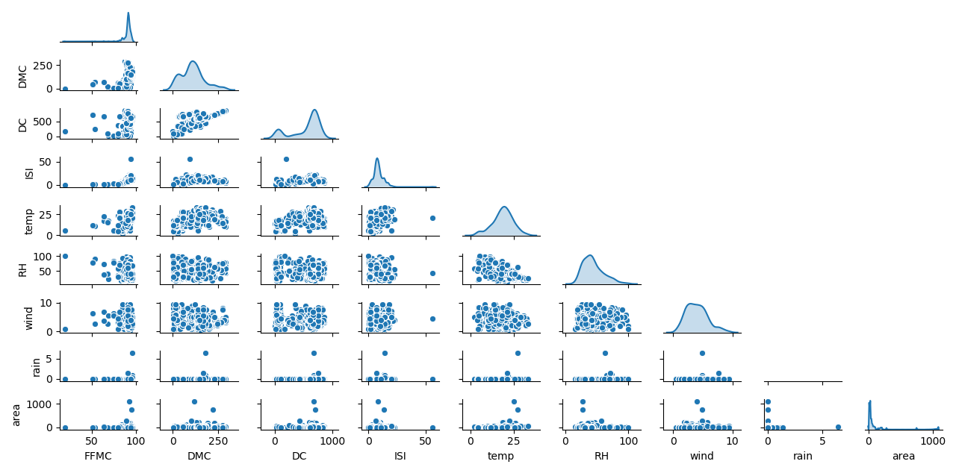**Scatter plot =**

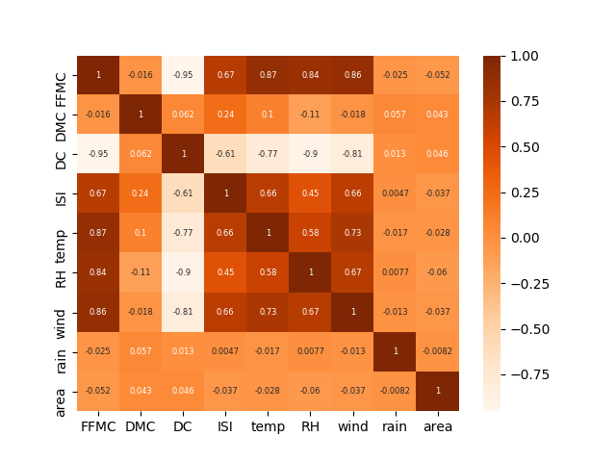**Correlation Coefficient (r) =**

Correlation between the Output feature and all input feature is very low as shown in the above heatmap, So the model we are building is not able to give us an accurate result. For perfect model building, we have to use some other input feature that having a high correlation with output.

**Model Building =** Building model by considering following parameters.

* **﻿﻿Kernel :-** rbf
* **﻿Gamma :-** 1
* **﻿Epsilon -** 0.01

**Accuracy of Model =**

* **Accuracy Train : -** Poor
* **Accuracy Test : -** Poor
* **RMSE Train : -** 67
* **RMSE Test :-** ﻿64

**Python code file**: - [Fireforests Analysis.py](https://github.com/nilaydeshmukh0/Support-Vector-Machine/blob/master/Fireforests%20Analysis/Fireforests%20Analysis.py)

**CONCLUSION :-**  We have to find out other more relevant feature for this predication.